**The Amazon Black Friday Rush: Overseeing the E-Commerce Surge**

**P. Nihaswi**

**4/8/2024**

**TABLE OF CONTENT**

|  |  |  |  |
| --- | --- | --- | --- |
| **CHAPTER NO** | **CHAPTER TITLE** | **PAGE NO** | |
| **1** | **INTRODUCTION** | **4-6** | |
| **2** | **PROJECT DECRIPTION** | **7-8** | |
| **3** | **PROJECT PLAN** | **9-10** | |
| **4** | **IMPLEMENTATION** | **11** |
| **5** | **RESULT** | **12-16** | |
| **6** | **CONCULATION** | **17-18** | |

**ABSTRACT**

The management of the Black Friday rush presents a significant challenge for e-commerce giants like Amazon, necessitating careful planning, technological integration, and adaptable strategies. This research aims to replicate and improve upon Amazon's actions during this busy shopping period, focusing on three key areas: predicting demand, optimizing warehouses, and streamlining deliveries. By utilizing advanced analytics and machine learning, Amazon can generate accurate demand forecasts, leading to better inventory management and reduced stockouts. Warehouse operations benefit from automated systems and efficient layouts, improving picking and packing efficiency and maximizing space usage. Effective logistics coordination, aided by route optimization software and strong carrier partnerships, ensures timely and cost-effective deliveries.

The outcomes of this research include improved demand forecasting accuracy, enhanced warehouse operational efficiency, on-time deliveries, and increased customer satisfaction. Key performance indicators such as forecast accuracy, order fulfillment time, on-time delivery rate, and customer satisfaction scores provide measurable benchmarks for success, with regular analysis and feedback loops promoting continuous improvement. Addressing challenges like forecasting errors, warehouse congestion, logistics disruptions, and customer dissatisfaction requires strategic planning, technological investments, and adaptable troubleshooting. Insights gained from this research, including valuable customer feedback, inform future improvements and innovations, guaranteeing a seamless and satisfying shopping experience. By focusing on these areas, Amazon can effectively manage the complexities of the Black Friday rush, enhancing operational efficiency and customer happiness while establishing a foundation for sustained growth and success in the competitive e-commerce industry.

**INTRODUTION**

In the United States, the day following Thanksgiving is commonly known as "Black Friday" and is traditionally considered the kickoff of the Christmas shopping season. This event takes place on the fourth Thursday of November. It is customary for businesses to provide special promotions on Black Friday, both in physical stores and online, in order to attract customers. Initially, Black Friday sales were primarily observed in the US market; however, over time and due to globalization, they have spread to numerous other countries, including India. While consumers see discount and promotional sales as an opportunity to purchase essential items while maximizing value through great deals and discounts (Santini et al., 2015), retailers perceive Black Friday sales as a beneficial strategy to increase their sales volume and draw in new customers. With the widespread use of the internet, many e-commerce platforms offer exclusive discounts and promotions during Black Friday sales.

In this research, we analyze how online shoppers perceive the Black Friday promotions offered by different e-commerce platforms and investigate the potential influence of ratio bias. Ratio bias refers to the inclination of individuals to consider probabilities presented as ratios of large numbers as more likely than probabilities of equal or even greater magnitude expressed as ratios of small numbers. The marketing strategies employed during Black Friday sales could potentially impact investors' perceptions, similar to how every strategic decision made by a company can influence its market performance and stock values. Investors closely monitor the marketing approaches adopted by different companies to anticipate the profitability of the business.

**Background**

Amazon was established by Jeff Bezos in July 1994, starting as an online bookstore. The business was initially run from Bezos's garage in Bellevue, Washington. The goal was to establish a platform that could offer a wide range of books to a large audience. This modest yet ambitious start laid the foundation for what would eventually become one of the most influential corporations globally.

Recognizing the internet's potential as a sales platform, Amazon quickly broadened its product range beyond books. By the end of the 1990s, the company was selling a diverse array of items, such as electronics, toys, clothing, and household goods. This expansion was facilitated by the creation of a sophisticated e-commerce platform that allowed third-party vendors to access Amazon's extensive customer base, further diversifying the products available on the website.

Amazon has always been a pioneer in technological advancements. Key milestones include:

**Amazon Prime:** Introduced in 2005, Amazon Prime provided customers with free two-day shipping for an annual fee. This service significantly increased customer loyalty and established new benchmarks for e-commerce delivery.

**Amazon Web Services (AWS)**: Launched in 2006, AWS delivers cloud computing services that have become a significant revenue source for the company. AWS offers a wide range of services, such as computing power, storage, and databases, to businesses and individuals worldwide.

**Kindle:** The introduction of the Kindle e-reader in 2007 transformed the way people read books, enabling Amazon to dominate the e-book market.

**Acquisitions:** Amazon has completed several strategic acquisitions, including Zappos (footwear and apparel), Whole Foods Market (groceries), and Ring (smart home security). These acquisitions have assisted Amazon in diversifying its offerings and entering new markets.

Amazon operates in numerous countries, with dedicated websites for many regions, including North America, Europe, Asia, and Latin America. The company has built an extensive global logistics network, including fulfillment centers, sortation centers, and delivery stations, enabling efficient order processing and delivery worldwide.

**Objectives**

The aim of this simulation is to create a thorough plan to manage the high demand during Black Friday for an online retail company. This involves making precise demand predictions, improving warehouse procedures, and guaranteeing smooth delivery operations to handle the surge in customer orders effectively. The objective is to reduce inventory shortages and delays, enhance customer contentment, and uphold operational effectiveness throughout the busiest shopping season.

**The scope of this simulation covers three critical areas:**

1. Demand Forecasting: Predicting customer demand to ensure adequate inventory levels.
2. Warehouse Optimization: Enhancing inventory management and order fulfillment processes within the warehouse.
3. Streamlined Delivery: Coordinating logistics to ensure timely and accurate delivery of orders.

**Stakeholders**

**Internal Stakeholders:**

**Senior Management**:

**Role:** Set strategic direction, allocate resources, and ensure alignment with organizational goals.

**Involvement:** Regularly updated, involved in decision-making, and part of the approval processes.

**Supply Chain Management Team:**

**Role:** Supervise end-to-end supply chain processes, including procurement, inventory management, and logistics.

**Involvement:** Plan, implement, and monitor supply chain strategies.

**Warehouse Operations Team:**

**Role:** Oversee warehouse activities such as receiving, storing, picking, and packing orders.

**Involvement:** Implement warehouse optimization strategies and monitor performance metrics.

**and Delivery Team:**

**Role:** Coordinate transportation and delivery of orders to customers.

**Involvement:** Implement route optimization and manage carrier partnerships.

IT and Data Analytics Team:

**Role:** Develop and maintain technological solutions, including demand forecasting models and warehouse management systems.

**Involvement:** Provide technical support and data analysis for decision-making.

**Customer Service Team:**

**Role:** Handle customer inquiries, complaints, and feedback.

**Involvement:** Provide insights from customer interactions and help improve the customer experience.

**Marketing and Sales Team:**

**Role:** Plan and execute Black Friday promotional campaigns and sales strategies.

**Involvement:** Align sales forecasts with supply chain capabilities and manage customer expectations.

**External Stakeholders:**

**Third-Party Logistics (3PL) Providers:**

* **Role:** Offer logistics and delivery services.
* **Involvement:** Managing transportation, warehousing, and delivery operations in collaboration with the logistics team.

**Technology Providers:**

* **Role:** Supply software and technological solutions for demand forecasting, warehouse management, and logistics coordination.
* **Involvement:** Implementing and maintaining technological systems, providing technical support, and offering training.

**Customers:**

* **Role:** End-users of the products and services provided.
* **Involvement:** Providing feedback on their shopping experience, which helps in improving operations and customer satisfaction.

***PROJECT DESCRIPTION***

**Problem statements**

1. Forecasting Demand: Anticipating the precise demand for numerous products can pose challenges, potentially resulting in stock shortages or excess inventory.

2. Challenges in Warehouse Optimization: Large numbers of orders may strain picking systems and impede order processing efficiency without proper optimization.

3. Issues with Logistics Coordination: Fulfilling delivery commitments can prove to be difficult, particularly during peak demand times, impacting customer contentment.

4. Enhancing Customer Satisfaction: Guaranteeing precise picking, packing, and shipping of orders is crucial to prevent returns and discontent among customers.

**Goals**

a. Enhance Forecast Accuracy:

Work on improving demand forecasting precision to guarantee that inventory levels match anticipated demand, reducing instances of stockouts and overstock.

b. Improve Warehouse Efficiency:

Optimize warehouse layout and procedures to effectively manage the rising number of orders, ensuring swift and precise picking and packing.

c. Streamline Logistics Management:

Efficiently coordinate with carriers and optimize delivery routes to guarantee punctual order deliveries and handle the growing delivery volume.

d. Boost Customer Satisfaction:

Attain exceptional levels of order accuracy and on-time delivery to fulfill customer expectations and uphold a favorable shopping experience.

**Objective**

Demand Prediction:

Create a predictive model for forecasting Black Friday demand accuracy of at least 95%.

Warehouse Enhancement:

Revamp the warehouse layout to boost picking efficiency by 30%.

Enhance process and technology integration to decrease packing time by 20%.

Logistics Management:

Collaborate with ample carriers to manage the increased volume, preventing shipping delays.

Streamline delivery routes to cut down average delivery time by 15%.

Customer Contentment: Ensure that 90% of deliveries are completed within the promised time frame.

**Methodology**

**a. Demand Forecasting**

1. **Data Collection**: Gather historical sales data, current market trends, and consumer behavior insights.
2. **Model Development**: Use time series analysis, machine learning algorithms (e.g., Random Forest, Neural Networks), and scenario planning to develop demand forecasts.
3. **Validation**: Test the forecasting model using historical data to validate its accuracy and adjust as necessary.

**b. Warehouse Optimization**

1. **Layout Design**: Analyze current warehouse layout and reconfigure it to optimize space utilization and minimize travel time for picking.
2. **Technology Integration**: Implement automated picking systems, barcode scanning, and real-time inventory tracking.
3. **Process Improvement**: Adopt best practices for packing efficiency and train staff to handle increased order volumes effectively.

**c. Logistics Coordination**

1. **Carrier Management**: Engage with multiple carriers and negotiate capacity commitments for peak periods.
2. **Route Optimization**: Use route optimization software to plan efficient delivery routes and reduce transit times.
3. **Real-Time Tracking**: Implement systems for real-time order and delivery tracking to enhance visibility and manage customer expectations.

**d. Customer Satisfaction**

1. **Quality Control**: Implement rigorous quality checks at picking and packing stages to ensure order accuracy.
2. **Communication**: Provide timely updates to customers regarding order status and expected delivery times.
3. **Feedback Mechanism**: Collect and analyze customer feedback to address issues promptly and continuously improve processes.

**PROJECT PLAN**

**1.timeline**

The project plan encompasses the preparation for Black Friday, which involves demand forecasting, warehouse optimization, logistics coordination, and risk management. The schedule spans several months leading up to Black Friday.

Pre-Planning Phase:

Week 1-2:

Establishment of the project team and allocation of roles.

Week 3-4:

Gather historical data and market insights.

Week 5-6:

Finalize warehouse layout changes and technology upgrades.

Develop logistics coordination plan, including carrier partnerships.

Week 7-8:

Train staff on new processes and technologies.

Establish real-time tracking and customer communication systems.

Execution Phase (Black Friday Week):

Week 9:

Supervise warehouse operations and ensure picking/packing efficiency.

Coordinate with logistics partners to manage delivery schedules.

Week 10:

Implement contingency plans for any issues that arise.

Provide customer support for order inquiries and issues.

Post-Event Phase (1 Week After Black Friday):

Week 11:

Analyze performance metrics (order accuracy, delivery times, etc.).

Collect customer feedback and review overall project performance.

Document lessons learned and recommend improvements for future events.

**Risk management**

* Order processing may be inefficient or delayed due to limited space or system malfunctions.
* Delays from carriers or failures in route optimization can lead to missed delivery deadlines.
* Problems with order accuracy or delivery times can impact customer confidence.
* Keep a close eye on real-time sales data and adjust inventory levels as needed.
* Utilize automated systems to improve efficiency in picking and packing.

**Implementation Plan:**

**Development Process and Technologies Used**

1. **Development process**

Utilize historical data for the creation of preliminary demand forecasting models.

Confirm the accuracy of models by analyzing previous Black Friday data.

Create efficient warehouse layouts and workflows.

Determine necessary technology upgrades, such as automated picking systems.

Forge partnerships with carriers and engage in capacity negotiations.

Formulate strategies for route optimization.

1. **Technologies Used**

* **Python Libraries (e.g., pandas, NumPy, stats models):**

For data manipulation and statistical analysis.

* **Machine Learning Algorithms (e.g., Random Forest, Boost):**

For predictive modeling and demand forecasting.

* **Tableau or Power Bi:** data visualization and reporting.

**Challenges and solutions**

1. **Demand Forecasting Issues**

Data Quality and Availability:

**Issue:** Incomplete or inaccurate historical sales data can hinder the development of reliable forecasting models.

**Resolution:** Ensure data quality by cleansing and validating historical sales data. Incorporate market trends and consumer sentiment analysis to enrich the data.

1. **Warehouse Efficiency**

**Problems Picking and Packing Efficiency:**

**Problem**: High order volumes can overwhelm manual picking and packing processes, leading to delays and errors.

**solution:** Deploy automated picking systems, such as robotic pickers and conveyor belts, to increase efficiency.

**INTERPRETATIN & ANALYSIS**

**Gender**

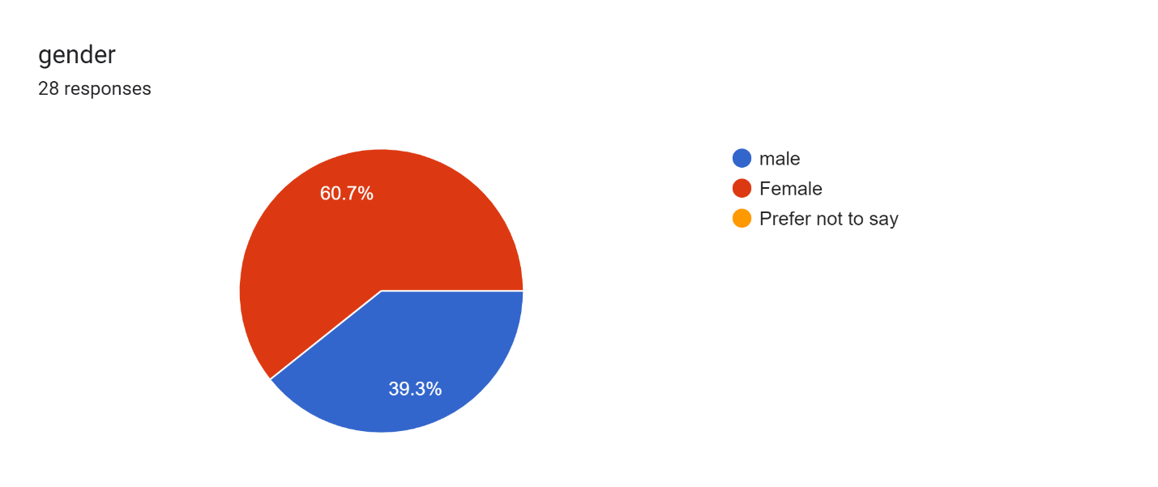

**Interpretation:** This pie chart shows that 30% are male, 70% are female.

1. **How would you rate your overall shopping experience on Amazon during Black Friday?**

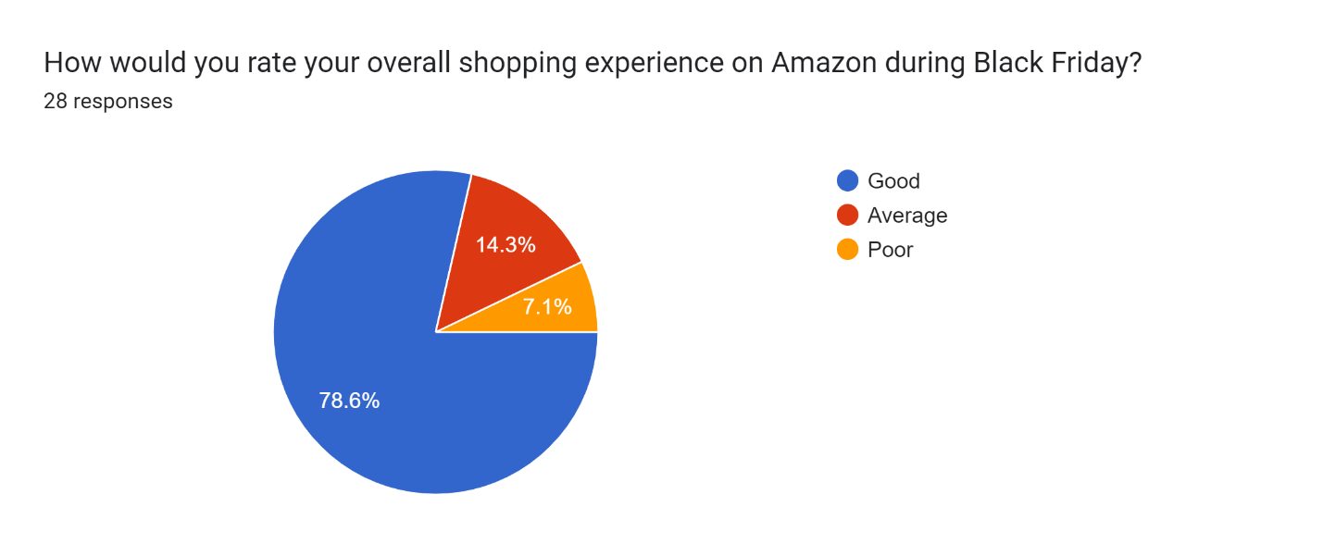

**Interpretation:** This pie chart shows that 80% have good shopping experience in amazon.

1. **How happy were you with the product search and filtering choices?**

Forms response chart. Question title: How happy were you with the product search and filtering choices?
. Number of responses: 28 responses.

**Interpretation:** This pie chart show that we can see that majority of people very satisfied and 25% is neutral with product search

1. **Were you content with the variety of products offered on Black Friday?** Forms response chart. Question title: Were you content with the variety of products offered on Black Friday?
   . Number of responses: 28 responses.

**Interpretation:** This pie chart shows 55%of them content with the product and 20% of people are not contented.

1. **Were there any problems with product availability (like items being out of stock)?** Forms response chart. Question title: Were there any problems with product availability (like items being out of stock)?
   . Number of responses: 28 responses.

**Interpretation:** This pie chart shows that 60% are saying that they are facing problems.

1. **Did you think the discounts provided were real and worthwhile?** Forms response chart. Question title: Did you think the discounts provided were real and worthwhile?
   . Number of responses: 28 responses.

Interpretation: This pie chart shows 45% are saying that yes

1. **What's your opinion on Amazon's customer service during Black Friday?**

Forms response chart. Question title: What&apos;s your opinion on Amazon&apos;s customer service during Black Friday?
. Number of responses: 28 responses.

**Interpretation:** This pie chart shows that 50% are satisfied with customer services

1. **Is your interstate to shop with Amazon again for the next Black Friday sale?** Forms response chart. Question title: Are you intrestated to shop with Amazon again for the next Black Friday sale?
   . Number of responses: 24 responses.

**Interpretation:** This pie chart shows that 70% are interstate to shop with amazon again.

1. **Would you suggest Amazon to your friends and family for Black Friday shopping?** Forms response chart. Question title: Would you suggest Amazon to your friends and family for Black Friday shopping?
   . Number of responses: 28 responses.

**Interpretation:** This pie chart shows that 65% are suggest to their friends and family.

**Gender and were there any problems with product availability (like items being out of stock)? Willing to spend by chi-square test:**

|  |  |  |  |  |
| --- | --- | --- | --- | --- |
| **Gender and were there any problems with product availability (like items being out of stock)?** | **Yes** | **No** | **Maybe** | **TOTAL** |
| **Male** | 7 | 4 | 0 | 11 |
| **Female** | 10 | 5 | 2 | 17 |
| **TOTAL** | 17 | 9 | 2 | 28 |

**Conclusion:**

In summary, effectively handling the Black Friday rush is essential for e-commerce giants like Amazon, considering the significant sales volume and customer demands during this peak period. This project highlights the significance of a holistic strategy that combines demand forecasting, warehouse optimization, and efficient delivery to address the complexities of Black Friday operations.

**Reference:**

Chopra, S., & Meindl, P. (2019). *Supply Chain Management: Strategy, Planning, and Operation*. Pearson.

Ballou, R. H. (2004). *Business Logistics/Supply Chain Management*. Pearson.

Kelle, P., & Nasr, L. (2003). *Supply Chain Management: A Strategic Approach*. Springer

McKinsey & Company. (2022). *The State of Logistics: Trends and Insights for E-commerce*. McKinsey & Company.

Deloitte. (2021). *2021 Holiday Retail Survey: Optimizing Supply Chains for Peak Seasons*. Deloitte Insights.

Harvard Business Review. (2020). *Optimizing the Supply Chain for Peak Seasons*. Retrieved from [HBR](https://hbr.org/)

Supply Chain Management Review. (2021). *Best Practices for Warehouse Management*. Retrieved from [Supply Chain Management Review](https://www.scmr.com/)

**Acknowledgements:**

We would like to express our deep appreciation to the individuals and resources who have made this project on managing the Black Friday rush for e-commerce operations possible. We extend our sincere thanks to the mentors, academic and industry experts, data and analytics teams, technology and tools providers, customer feedback contributors, team members, as well as our family and friends for their invaluable support and contributions. Your involvement has been crucial in the successful completion of this project.